Design software:

**CAD software used:** Fution360

**Link:** <https://www.autodesk.com/products/fusion-360/subscribe?plc=F360B&term=1-YEAR&support=ADVANCED&quantity=1>

**Cost:** $310 per/year

**Student licence:** Free

**ITEM #1:** Tool flange holder:

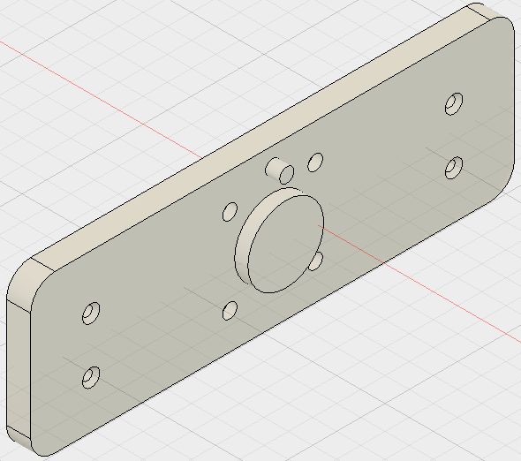

**Folder path:** master/Marker Phantom/New Design/No detector/

**Materials:** Plastic/PMMA

**ITEM #2:** KIM phantom design No detector:

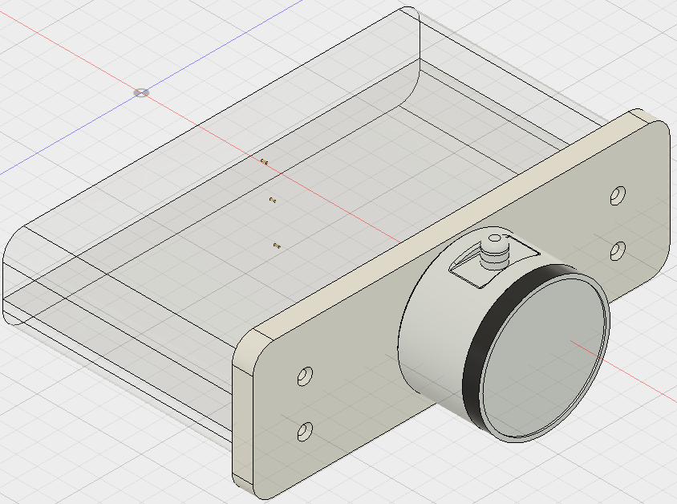

**ITEM #3:** KIM phantom design with detector:

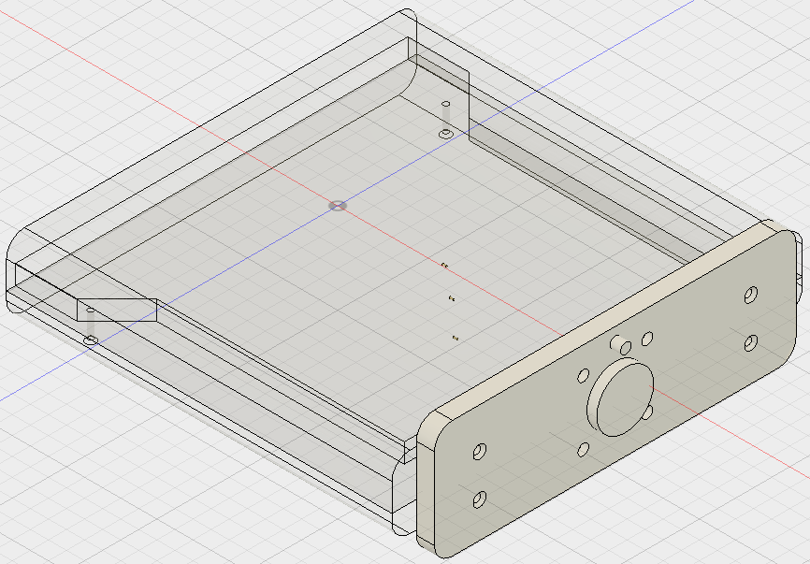

**Folder path:** master/Marker Phantom/New Design/

**Materials:** Plastic/PMMA (main block), gold markers

**ITEM #4:** Markerless phantom design, no detector:

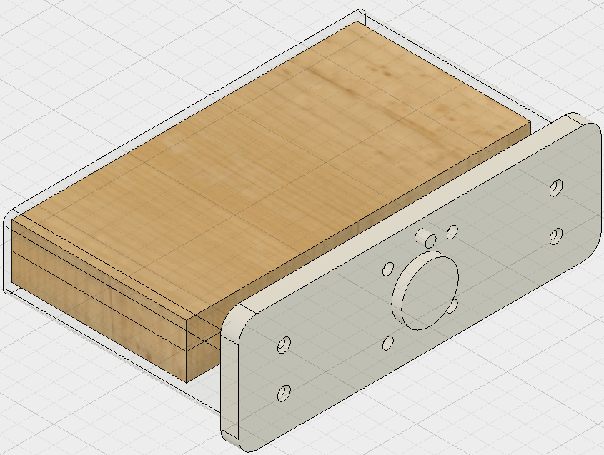

**ITEM #5:** Markerless phantom design, no detector:

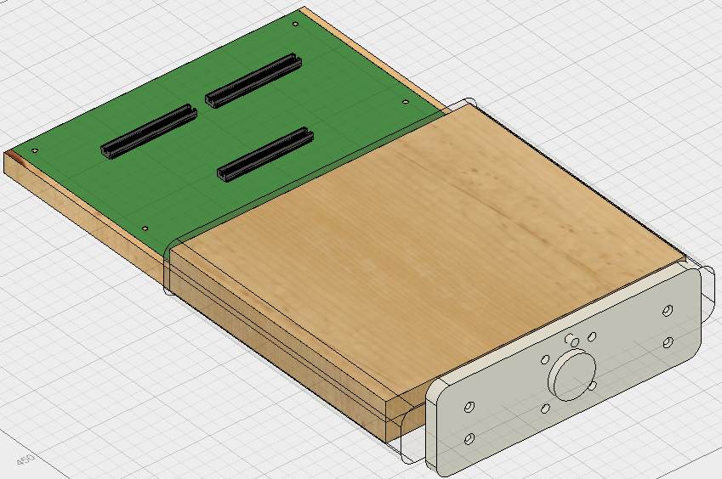

**Folder path:** master/Markerless Phantom/New Design/

**Materials:** Plastic/PMMA (main block), PMMA balls, wood (timber) insert

**ITEM #6:** Robot base design:

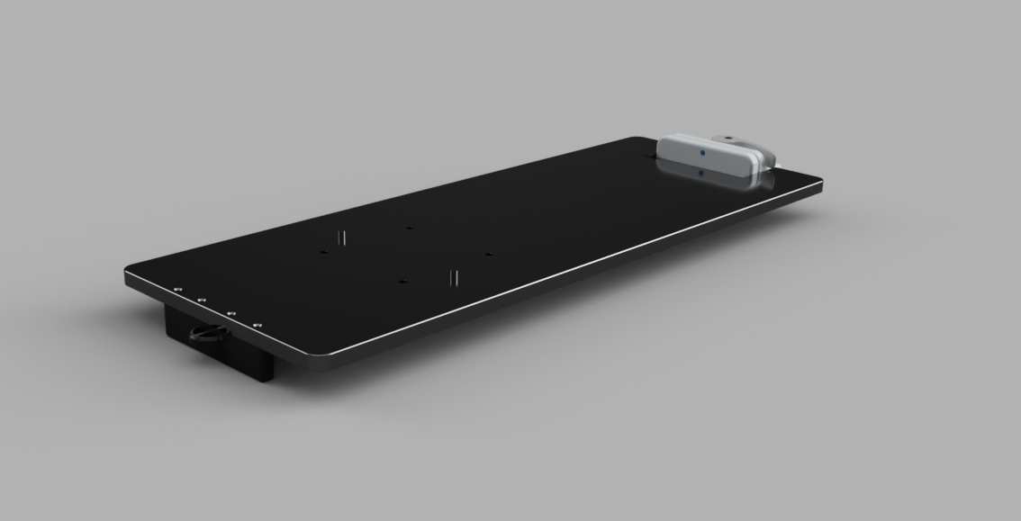

**Folder path gen1:** master/Base/

**Folder path gen2:** master/Base/Base gen-2/

**Materials:** Aluminium

**Note:** All drawings specifications for the UR3 robot can be found on their website in the following link: <https://www.universal-robots.com/download/>

**ITEM #7:** MagicPlate-512 holder:

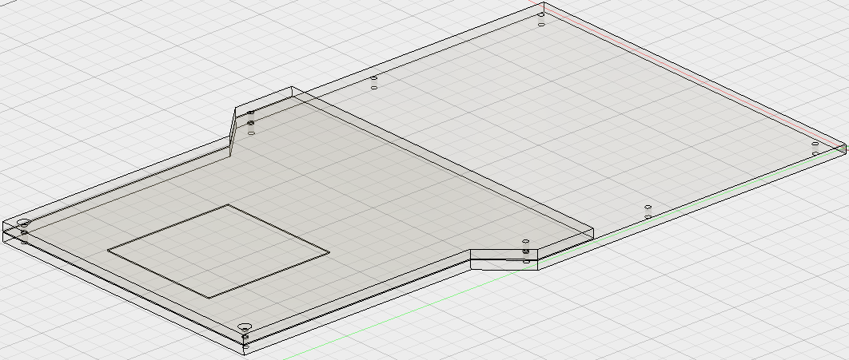

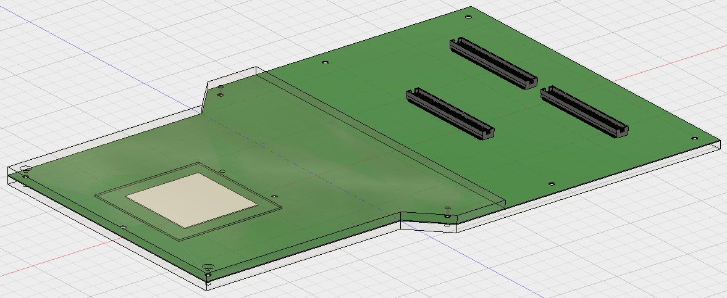

**Folder path:** master/Marker Phantom/New Design/

**Materials:** Plastic/PMMA (main block)